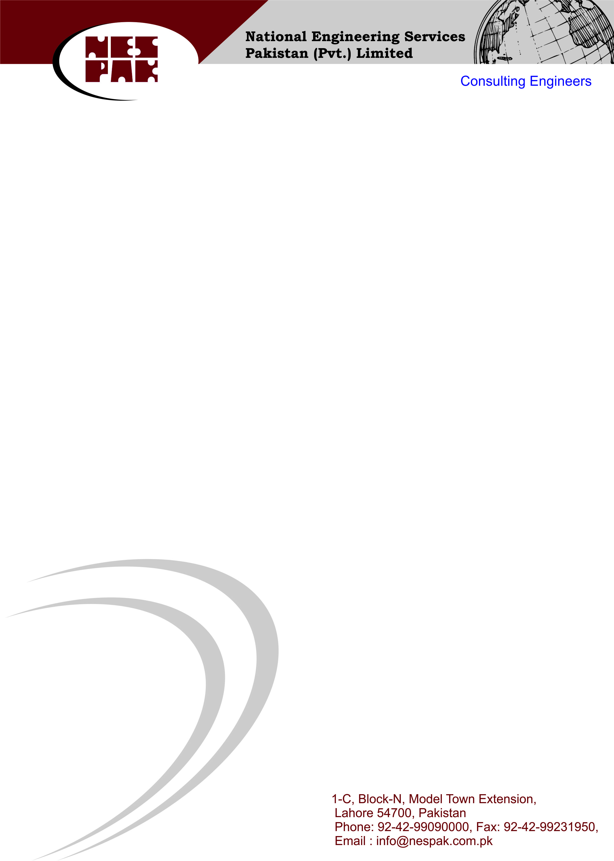

Dated: <To2>

**TO WHOM IT MAY CONCERN**

This is to certify that Mr. <Name> S/O <fname> was in the employment of our company from <From2> to <To2> in the capacity of <Designation> at IT Tower Gulberg Lahore.

This certificate was given to him upon his request without any obligations towards the company.

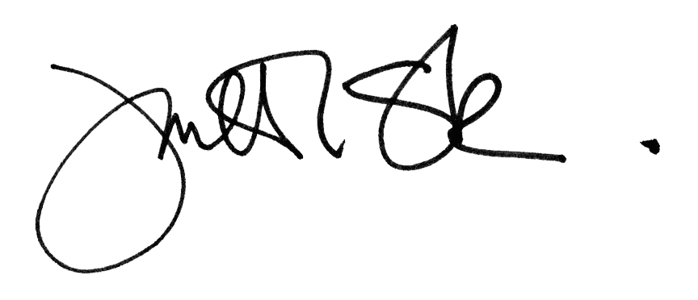

Anwar Zuarub

Incharge Project